Kids Menu

Please order from the Riverbank Kitchen Bar.
Served 10am-3pm & Pre-Show (last orders 30 mins before show begins).

Soup of the Day (Allergens change with soup, ask server) £3.50
Served with white or brown bread (G*).

Sandwiches £5.00
Half sandwich on white or brown bread, or baguette (G*). With salad garnish & animal shaped crisps.

Ham & Cheese (D)
Just Ham
Just Cheese (D)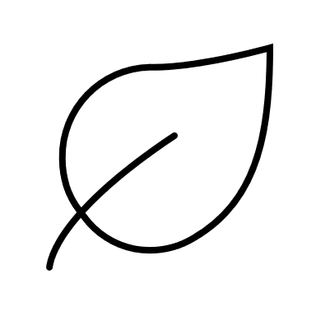
Tuna Mayo (E, F)

Half Jacket Potato £5.50
With a salad garnish.

Just Beans
Beans & Cheddar Cheese (D)
Tuna Mayo (E, F)

Baked Beans on Toast (G*) £4.50
Served on white or brown bread (G*).

Mac ‘n’ Cheese (D, G, Mu) £6.00
Served with a salad garnish & a half garlic baguette (G*, Su).

Chicken Nuggets & Chips (G) £6.50
Served with your choice or garden peas or baked beans.

Sausage & Chips (C, G, Mu, Su) £6.50
Served with your choice or garden peas or baked beans.

Fish Fingers & Chips (F, G)* £6.50
Served with your choice or garden peas or baked beans.

Scampi & Chips (F, G, Sh) £7.50
Served with your choice or garden peas or baked beans.
Please inform your server if you have ANY allergies.

Allergens are displayed by what is present in the dish.
C – Celery, D – Milk/Dairy, E – Eggs, F – Fish,
G – Cereals containing Gluten, L – Lupin, Mo – Molluscs,
Mu – Mustard, N – Nuts, P – Peanuts, S – Sesame,
Sh – Shellfish/Crustaceans, So – Soya, Su – Sulphur Dioxide

G* – Gluten free option available, ask your server.
– Suitable for vegetarians.
* - Vegan option available, ask your server.
– Suitable for vegans.

A list of allergens is available on request. Everything is freshly prepared in our kitchen, so we can adapt most dishes.
Scan this QR code to see what’s coming up at the theatre for families and children!



Kids Menu

Please order from the Riverbank Kitchen Bar.
Served 10am-3pm & Pre-Show (last orders 30 mins before show begins).

Soup of the Day (Allergens change with soup, ask server) £3.50
Served with white or brown bread (G*).

Sandwiches £5.00
Half sandwich on white or brown bread, or baguette (G*). With salad garnish & animal shaped crisps.

Ham & Cheese (D)
Just Ham
Just Cheese (D)
Tuna Mayo (E, F)

Half Jacket Potato £5.50
With a salad garnish.

Just Beans
Beans & Cheddar Cheese (D)
Tuna Mayo (E, F)

Baked Beans on Toast (G*) £4.50
Served on white or brown bread (G*).

Mac ‘n’ Cheese (D, G, Mu) £6.00
Served with a salad garnish & a half garlic baguette (G*, Su).

Chicken Nuggets & Chips (G) £6.50
Served with your choice or garden peas or baked beans.

Sausage & Chips (C, G, Mu, Su) £6.50
Served with your choice or garden peas or baked beans.

Fish Fingers & Chips (F, G)* £6.50
Served with your choice or garden peas or baked beans.

Scampi & Chips (F, G, Sh) £7.50
Served with your choice or garden peas or baked beans.
Please inform your server if you have ANY allergies.

Allergens are displayed by what is present in the dish.
C – Celery, D – Milk/Dairy, E – Eggs, F – Fish,
G – Cereals containing Gluten, L – Lupin, Mo – Molluscs,
Mu – Mustard, N – Nuts, P – Peanuts, S – Sesame,
Sh – Shellfish/Crustaceans, So – Soya, Su – Sulphur Dioxide

G* – Gluten free option available, ask your server.
– Suitable for vegetarians.
* - Vegan option available, ask your server.
– Suitable for vegans.

A list of allergens is available on request. Everything is freshly prepared in our kitchen, so we can adapt most dishes.
Scan this QR code to see what’s coming up at the theatre for families and children!

